Digital Design Diploma

# **Assignment 4**

# **Sequential Logic Design**

|  |  |
| --- | --- |
| **Name** | كريم حسن عاطف علي |
| **Group** | G2 |

**Submitted to: Eng. Kareem Waseem**

1. 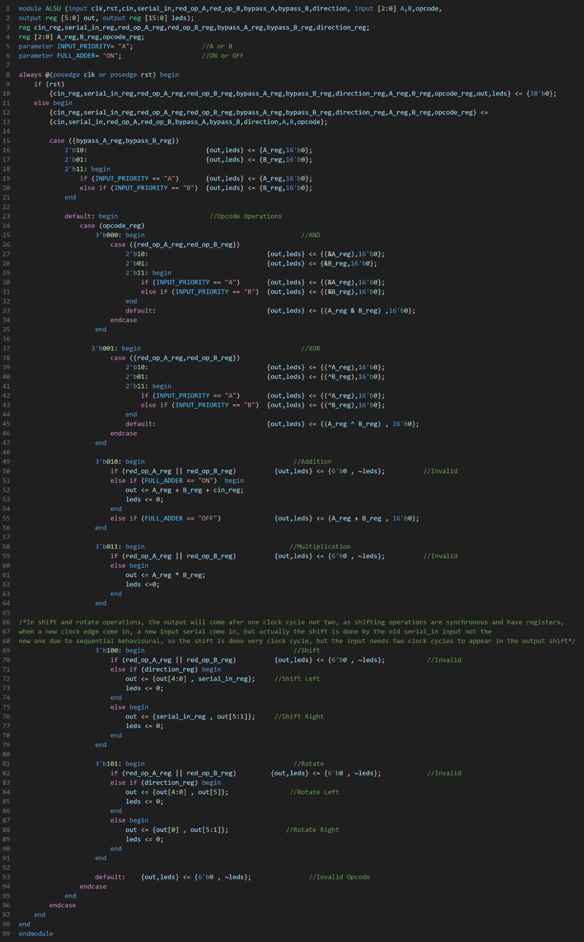**ALSU:**

Figure1: Q1 Code

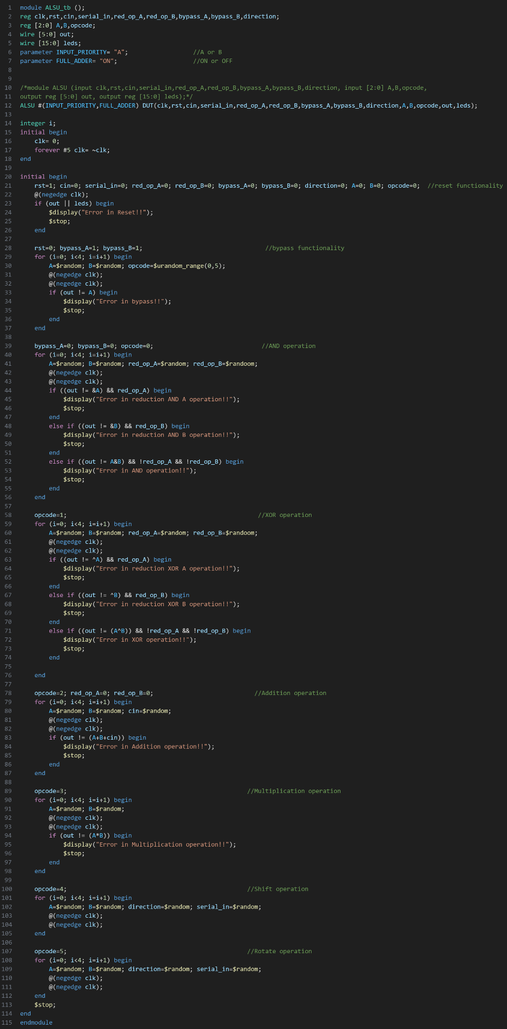

Figure2: Q1 Testbench

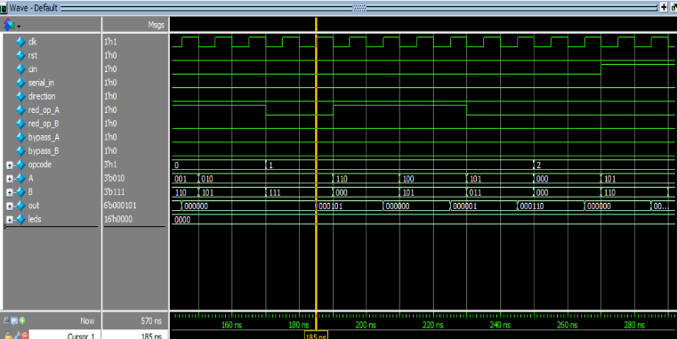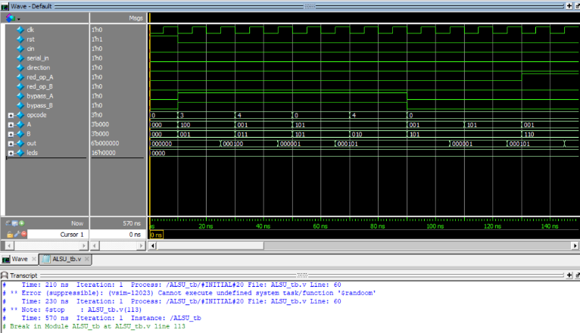

Figure4: Q1 Wave2

Figure3: Q1 Wave1

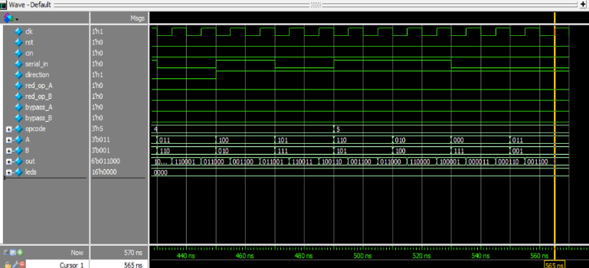

Figure6: Q1 Wave4

Figure5: Q1 Wave3

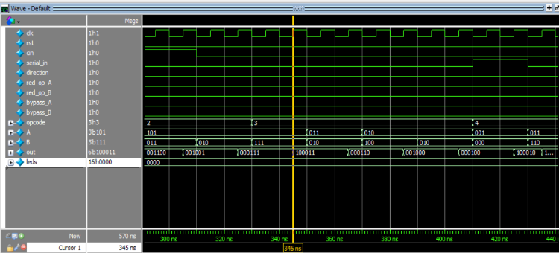

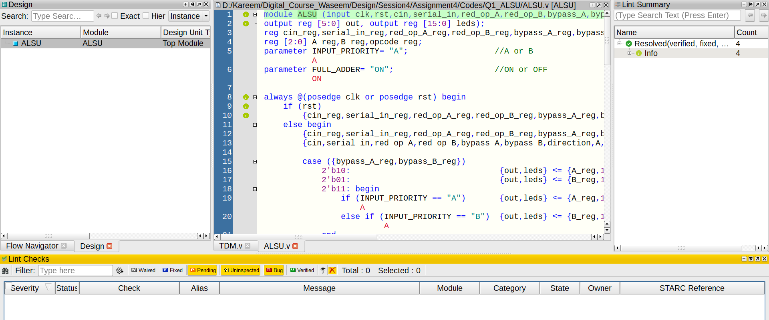

Figure7: Q1 Lint

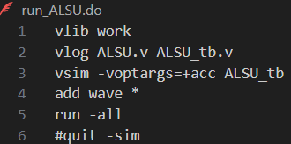

Figure8: Q1 DO File

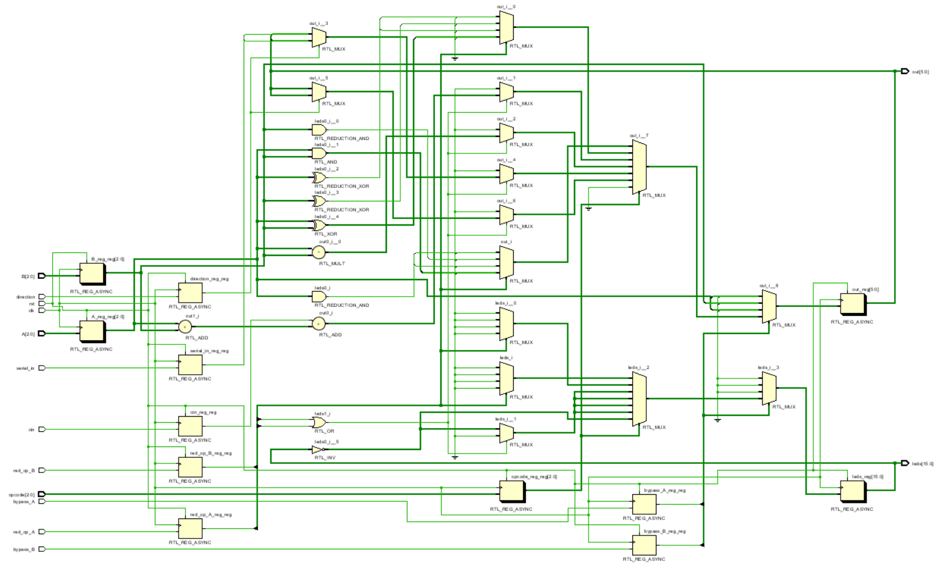

Figure9: Q1 RTL

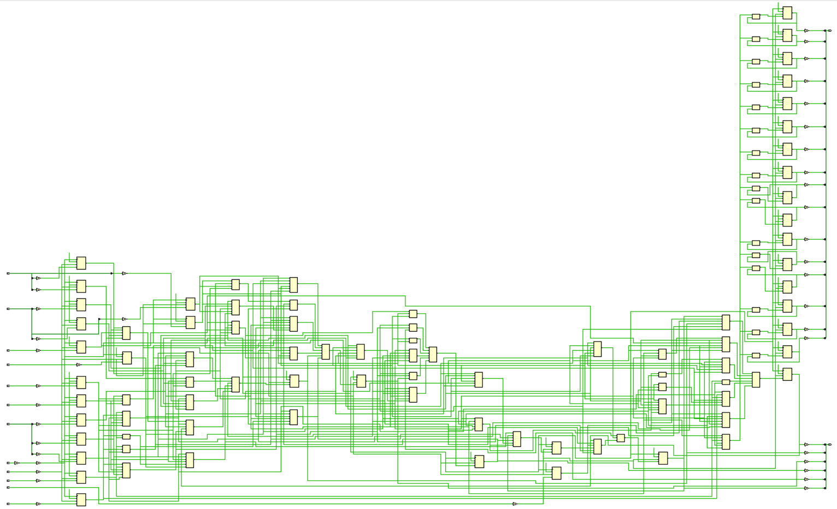

Figure10: Q1 Synthesis

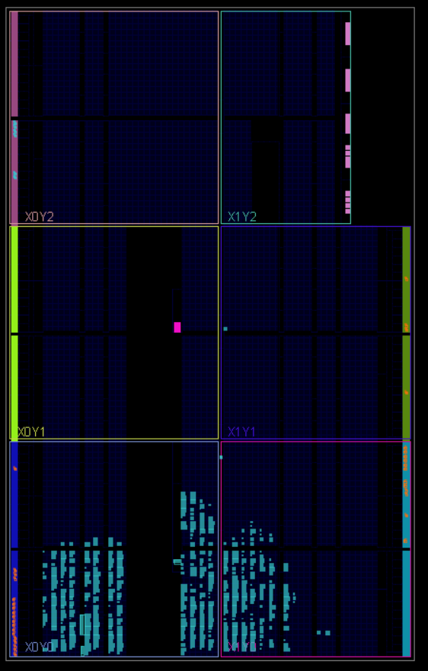

Figure11: Q1 Device

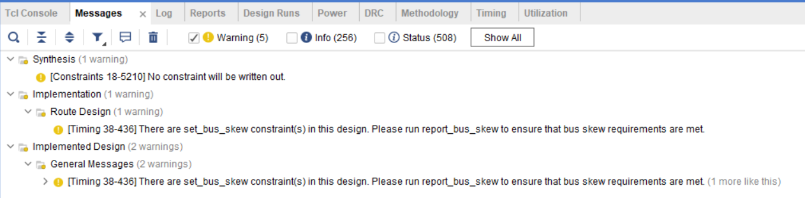

Figure12: Q1 Messages

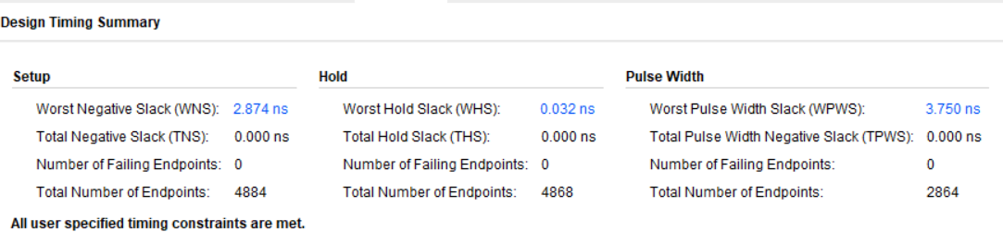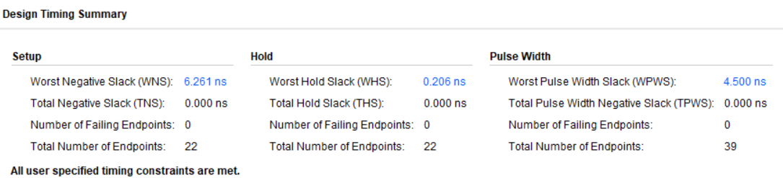

Figure13: Q1 Synthesis Timing Report

Figure14: Q1 Implementation Timing Report

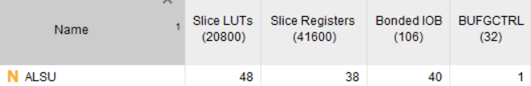

Figure15: Q1 Synthesis Utilization Report

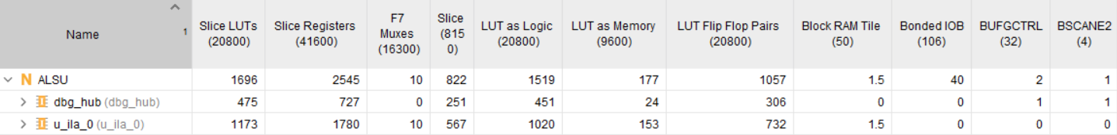

Figure16: Q1 Implementation Utilization Report

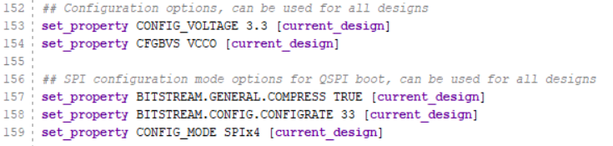

Figure17: Q1 Constraints File

1. 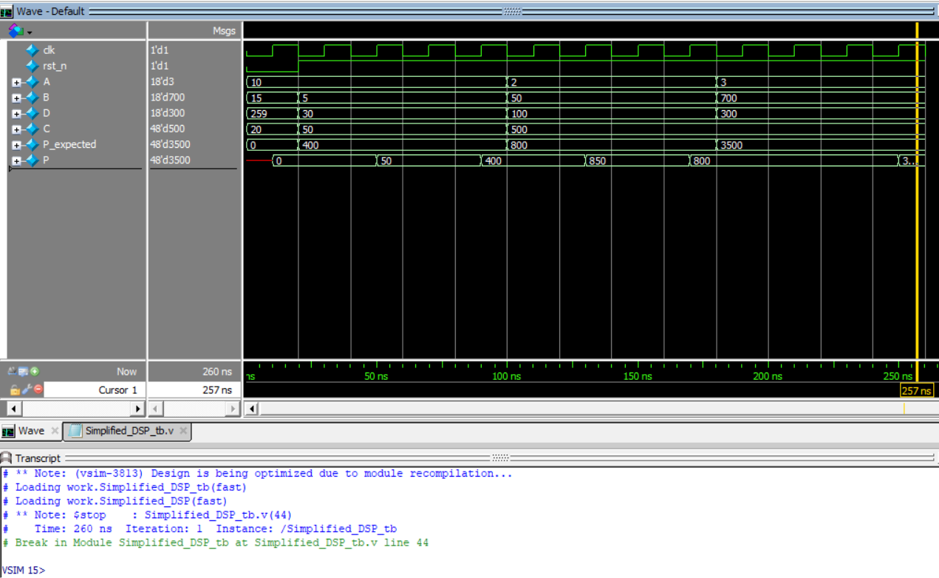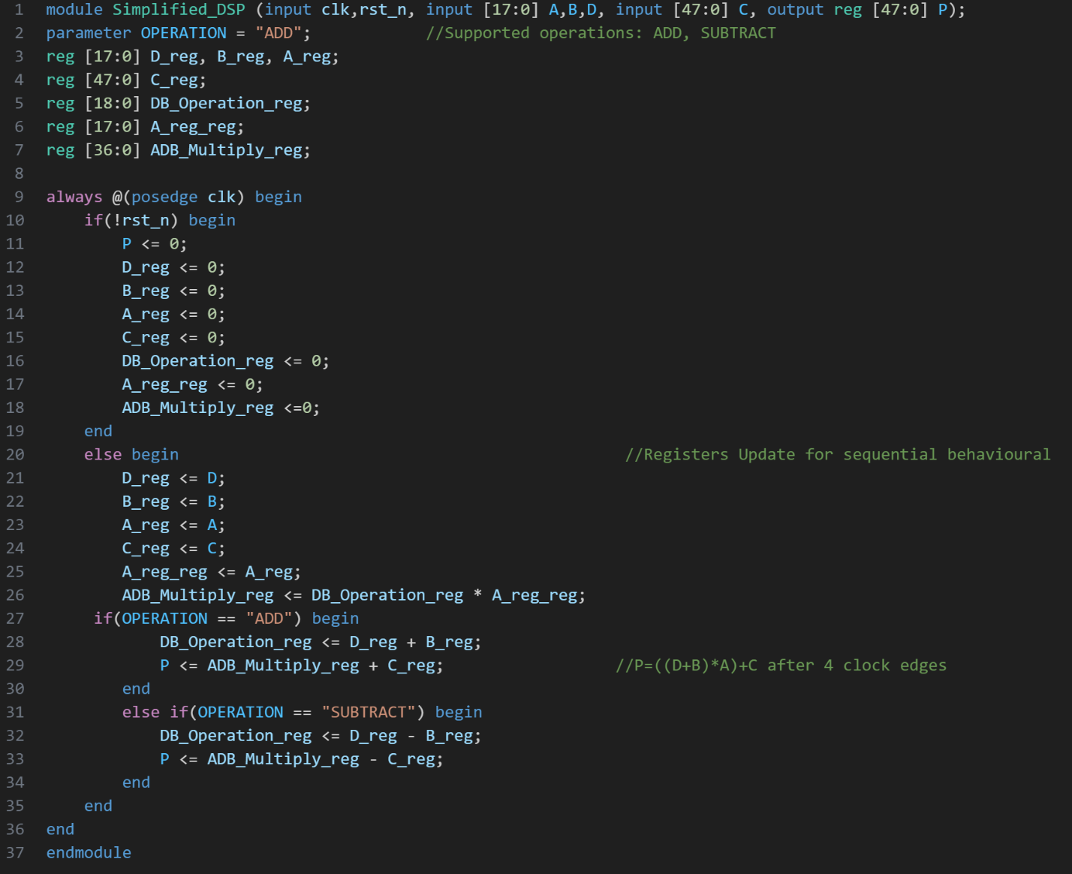**Simplified DSP:**

Figure18: Q2 Code

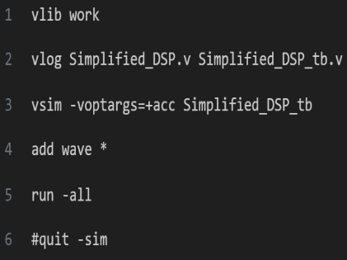

Figure20: Q2 Do File

Figure19: Q2 Wave

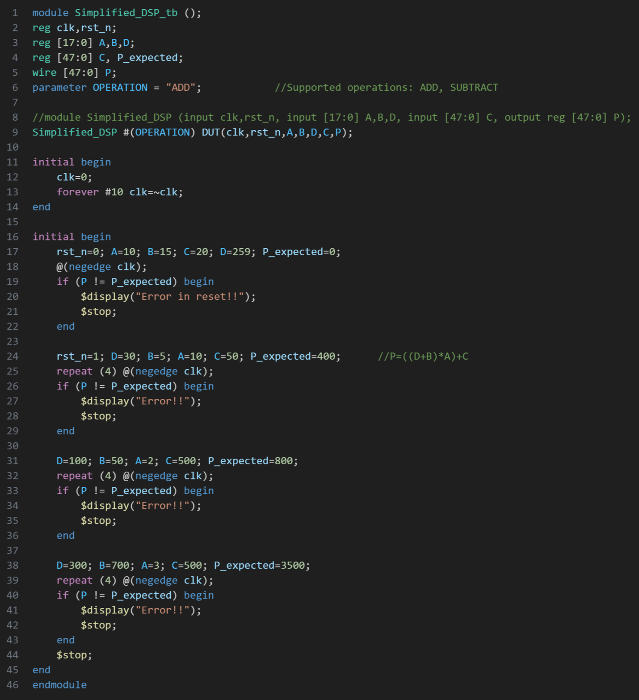

Figure21: Q2 Testbench

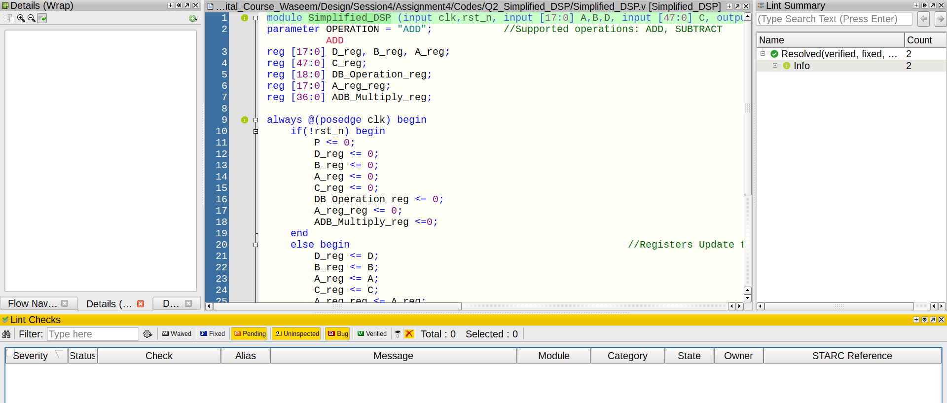

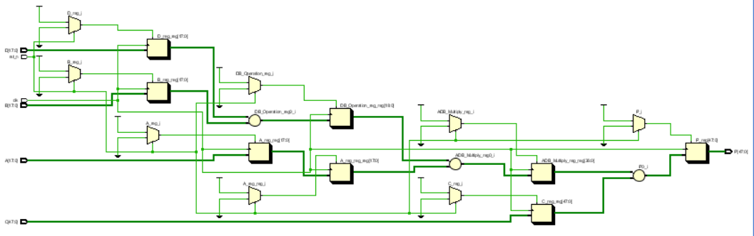

Figure22: Q2 Lint

Figure23: Q2 RTL

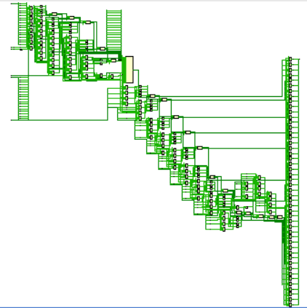

Figure24: Q2 Synthesis

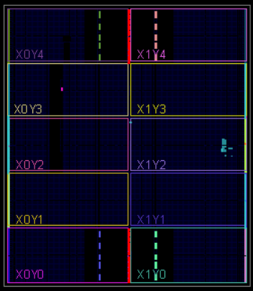

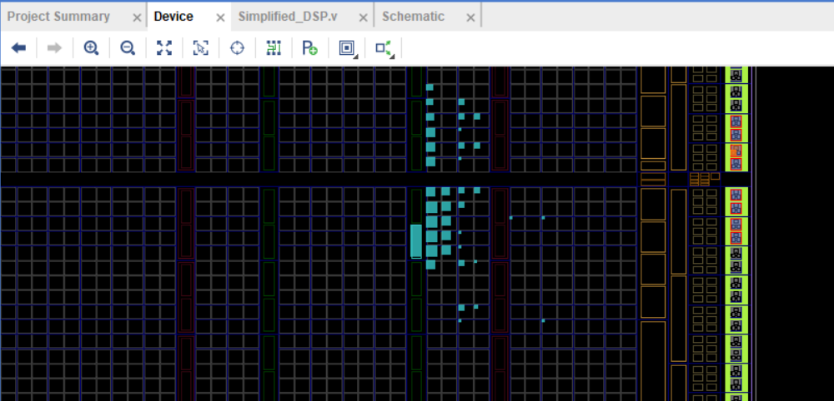

Figure25: Q2 Device1

Figure26: Q2 Device2

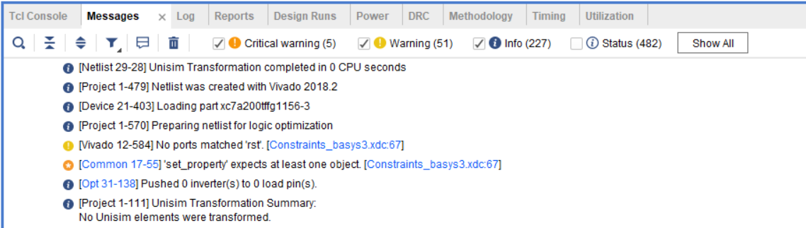

Figure27: Q2 Messages

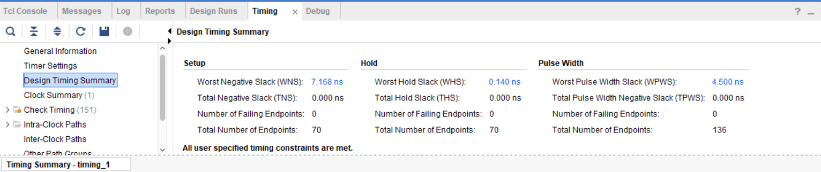

Figure28: Q2 Synthesis Timing Report

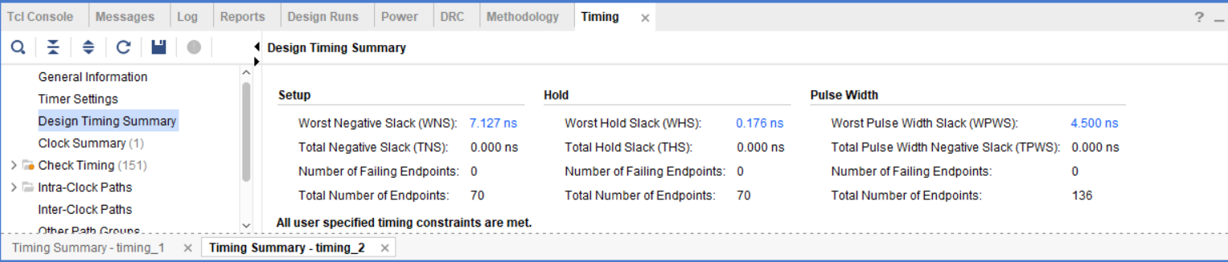

Figure29: Q2 Implementation Timing Report

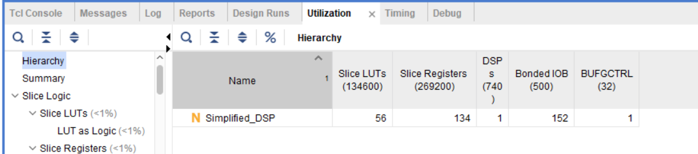

Figure30: Q2 Synthesis Utilization Report

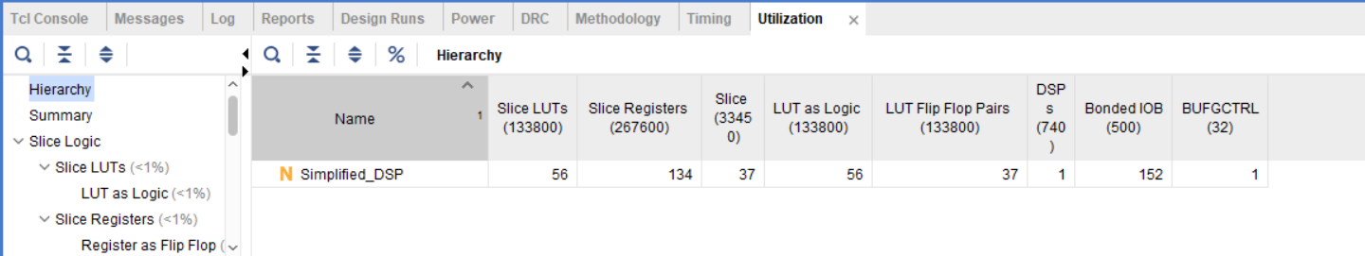

Figure31: Q2 Implementation Utilization Report

1. 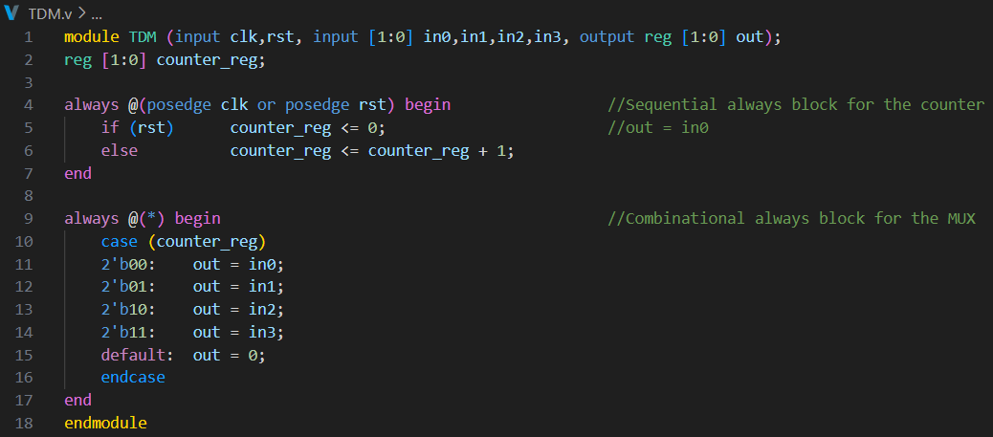**TDM:**

Figure32: Q3 Code

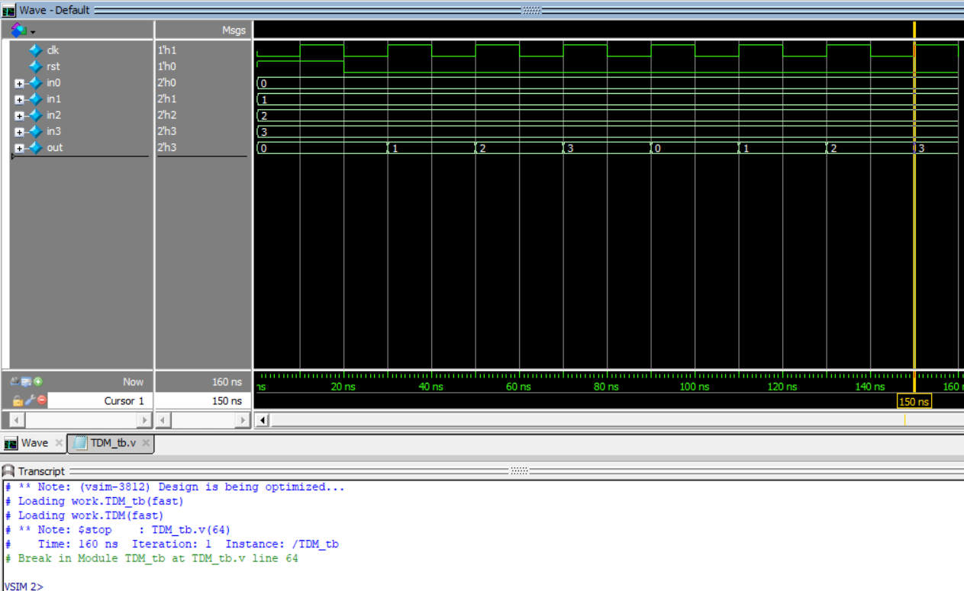

Figure33: Q3 Wave

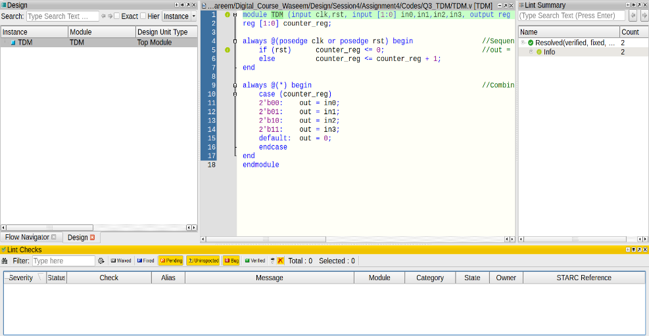

Figure34: Q3 Lint

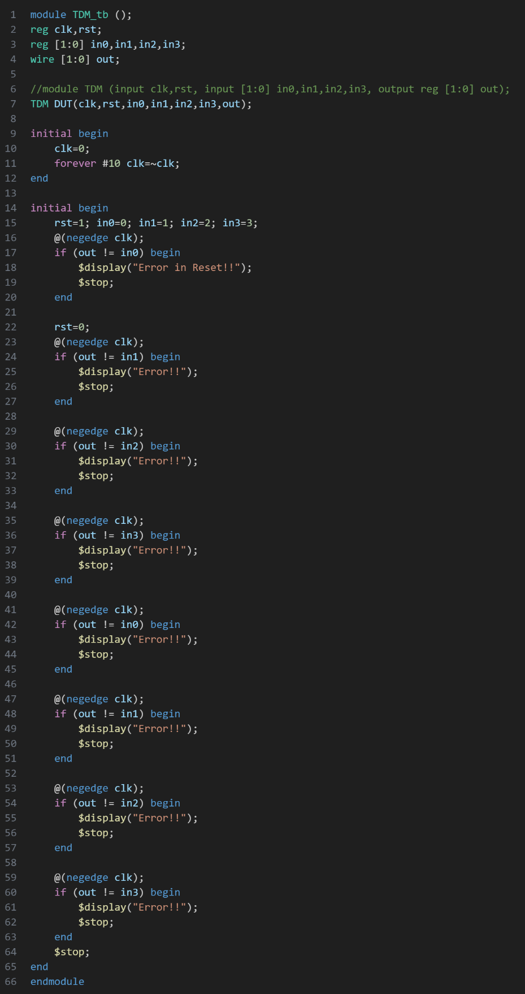

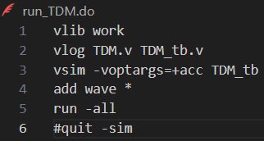

Figure36: Q3 DO File

Figure35: Q3 Testbench

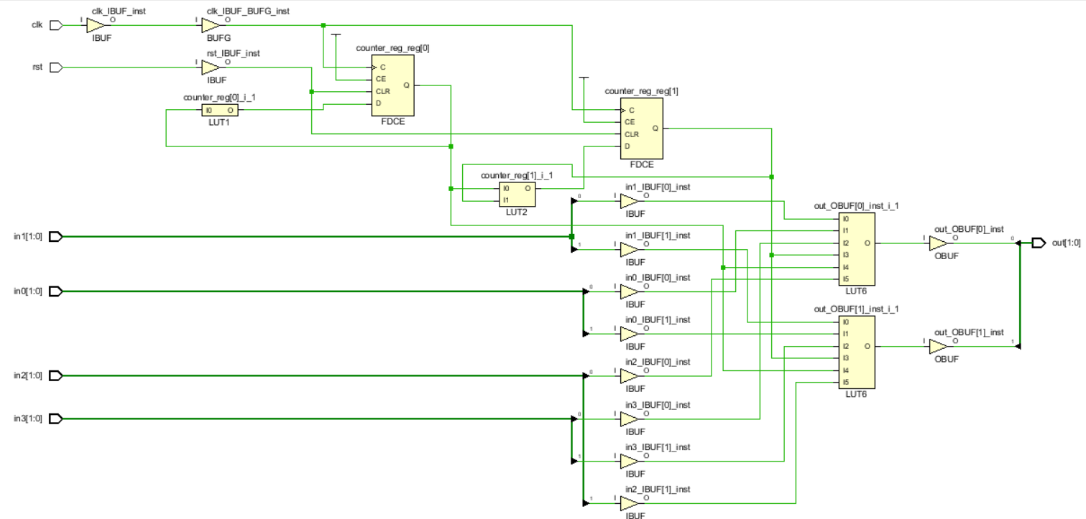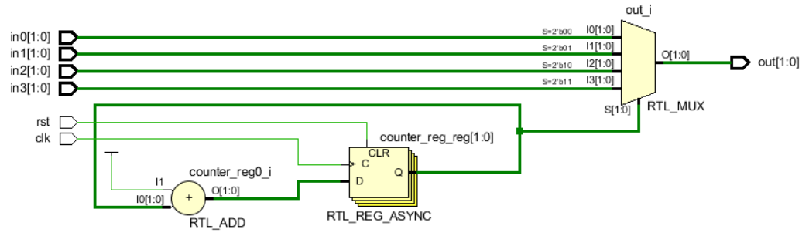

Figure38: Q3 Synthesis

Figure37: Q3 RTL

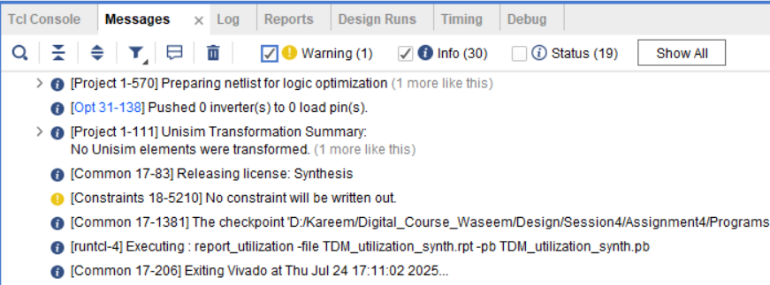

Figure39: Q3 Messages

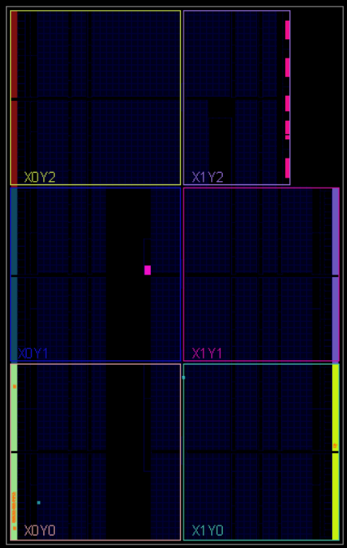

Figure40: Q3 Device1

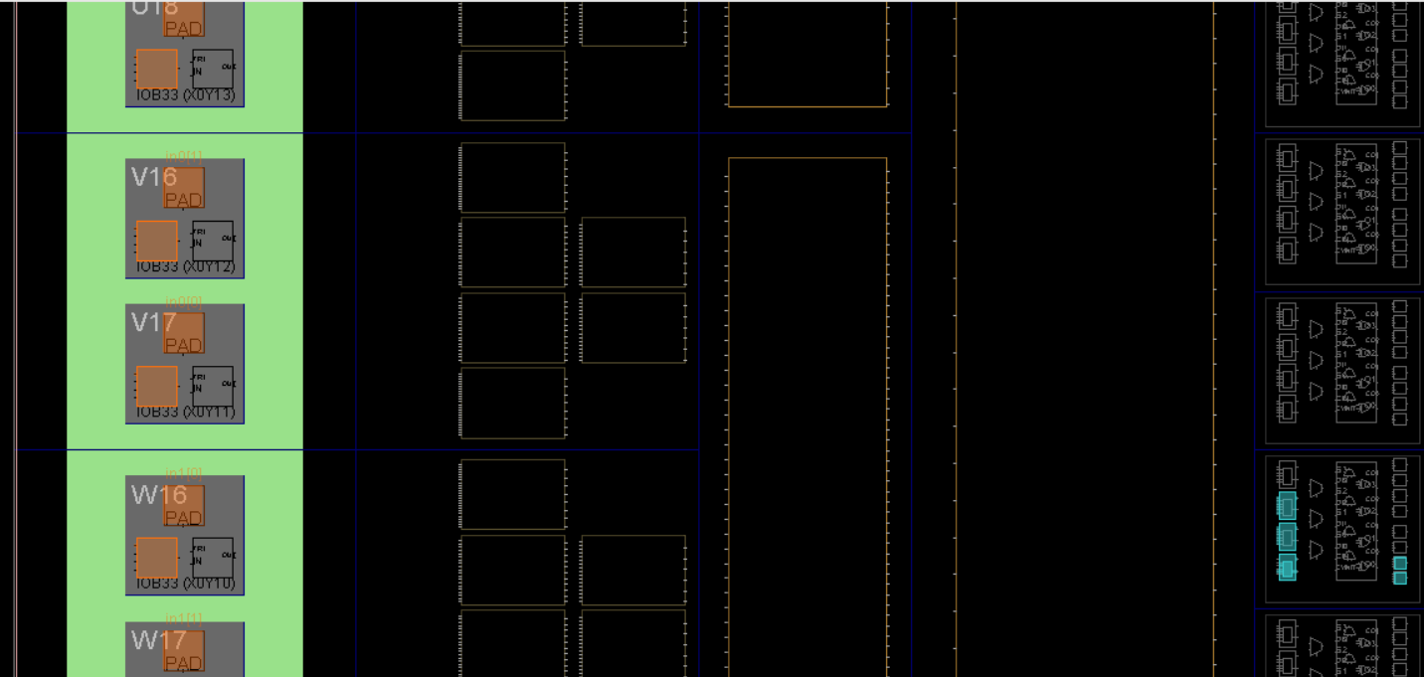

Figure41: Q3 Device2

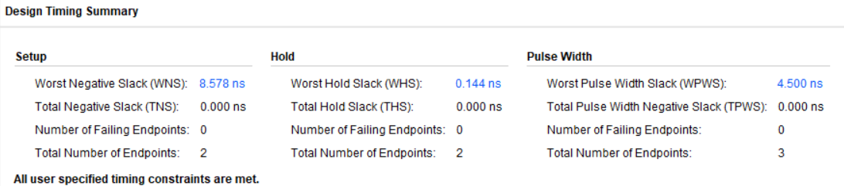

Figure42: Q3 Synthesis Timing Report

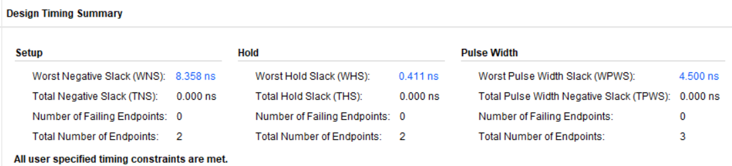

Figure43: Q3 Implementation Timing Report

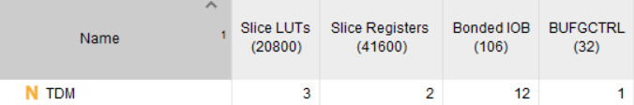

Figure44: Q3 Synthesis Utilization Report

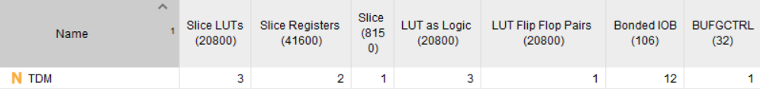

Figure45: Q3 Implementation Utilization Report